**DAILY ONLINE ACTIVITIES SUMMARY**

|  |  |  |  |  |  |  |  |  |
| --- | --- | --- | --- | --- | --- | --- | --- | --- |
| **Date:** | **20/06/2020** | | | | | **Name:** | **POOJA D S** | |
| **Sem & Sec** | **4th Sem 'B' Section** | | | | | **USN:** | **4AL18CS056** | |
| **Online Test Summary** | | | | | | | | |
| **Subject** | | **Data Communication** | | | | | | |
| **Max. Marks** | | **30** | | **Score** | | | **23** | |
| **Certification Course Summary** | | | | | | | | |
| **Course** | **Introduction to Information Security** | | | | | | | |
| **Certificate Provider** | | | **Great Learning Academy** | | **Duration** | | | **5.5 hour** |
| **Coding Challenges** | | | | | | | | |
| **Problem Statement:** A user will input two strings, and we find if one of the strings is a sub sequence of the other. Program prints “yes” if either the first string is a sub sequence of the second string or the second string is a sub sequence of the first string. Assume that, the length of the first string is smaller than or equal to the length of the second string. Assume that, the length of the first string is smaller than or equal to the length of the second string. | | | | | | | | |
| **Status: completed** | | | | | | | | |
| **Uploaded the report in Github** | | | | | **yes** | | | |
| **If yes Repository name** | | | | | <https://github.com/dspooja/C-coding>  <https://github.com/dspooja/Java-coding> | | | |
| **Uploaded the report in slack** | | | | | **yes** | | | |

Online Test Details: (Attach the snapshot and briefly write the report for the same)

Certification Course Details: (Attach the snapshot and briefly write the report for the same)

Coding Challenges Details: (Attach the snapshot and briefly write the report for the same)

ONLINE TEST DETAILS:

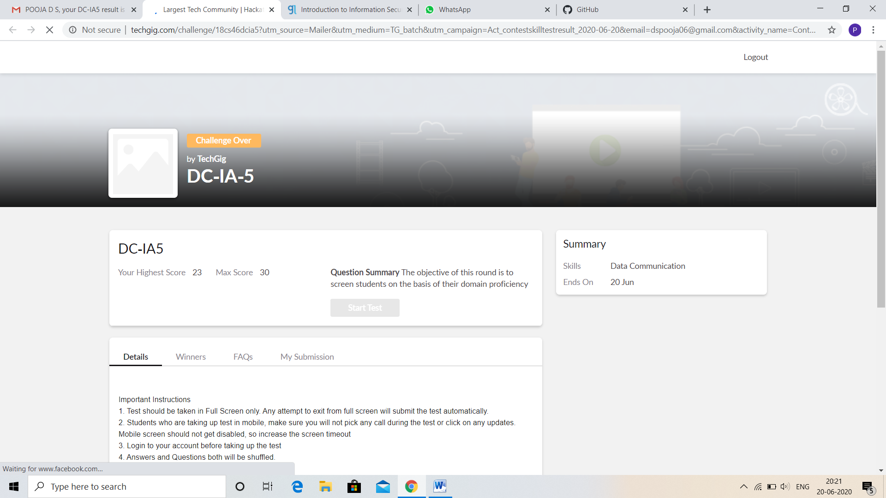

CERTIFICATION COURSE DETAILS:

* My Certification Course is Introduction to Information Security
* **The concepts covered in** Introduction to Information Security **are:**
* What is the future of cryptography
* Introduction to software security Lesson-1

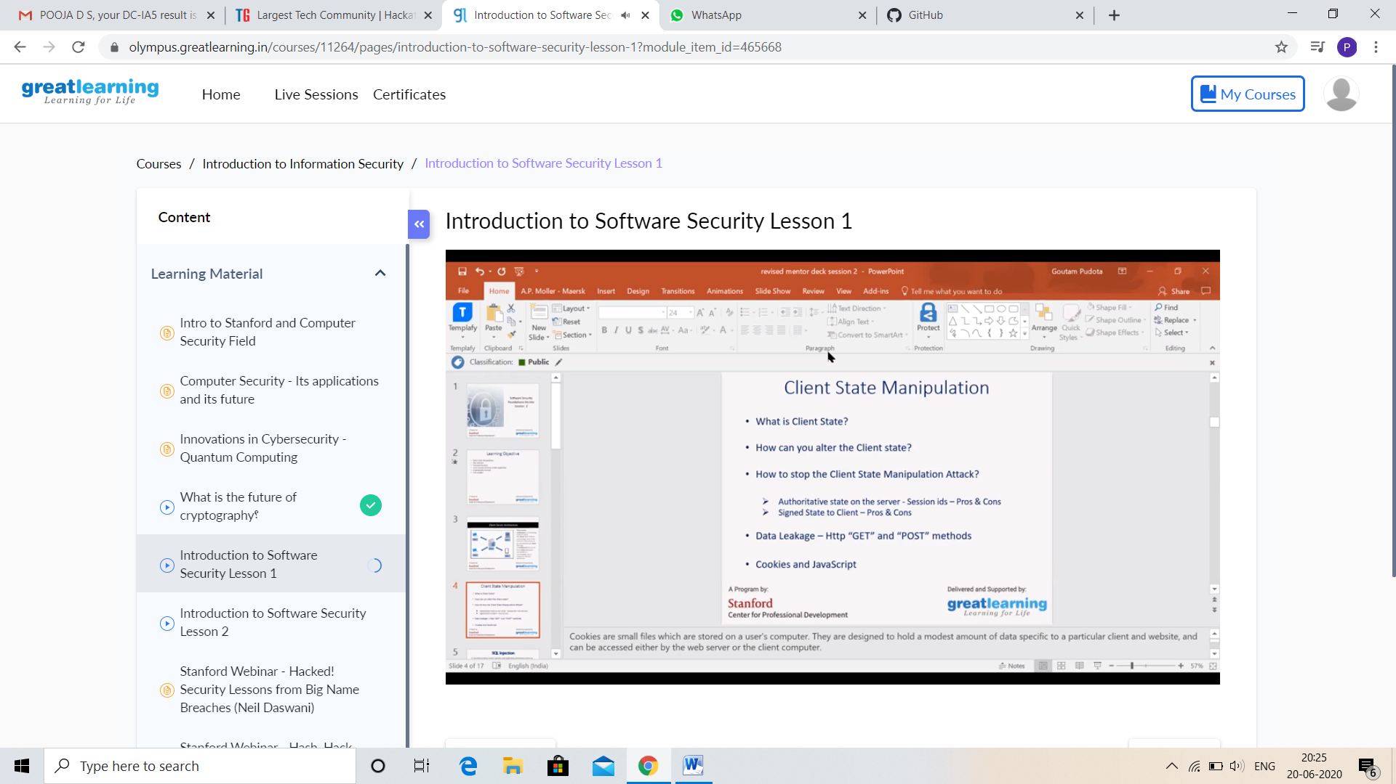

And I Participation in the Webinar “INTERNET OF THINGS USING ARDUINO”. I got good Experience. And this is my certificate

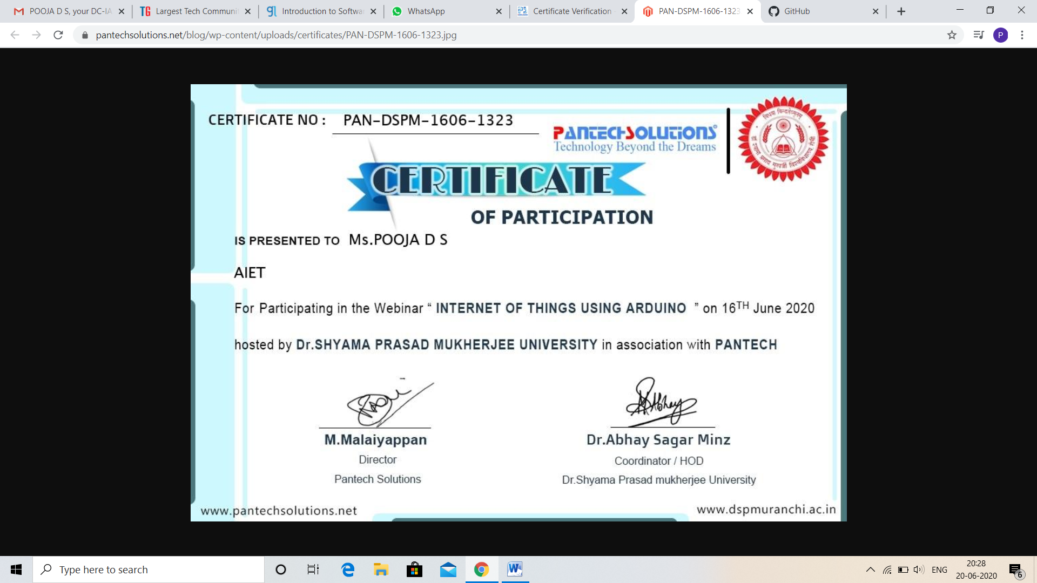

CODING CHALLENGES DETAILS:

Problem statement 1:

Program that compares counting words in files using an ArrayList and a Map.

Solution: Uploaded in github.

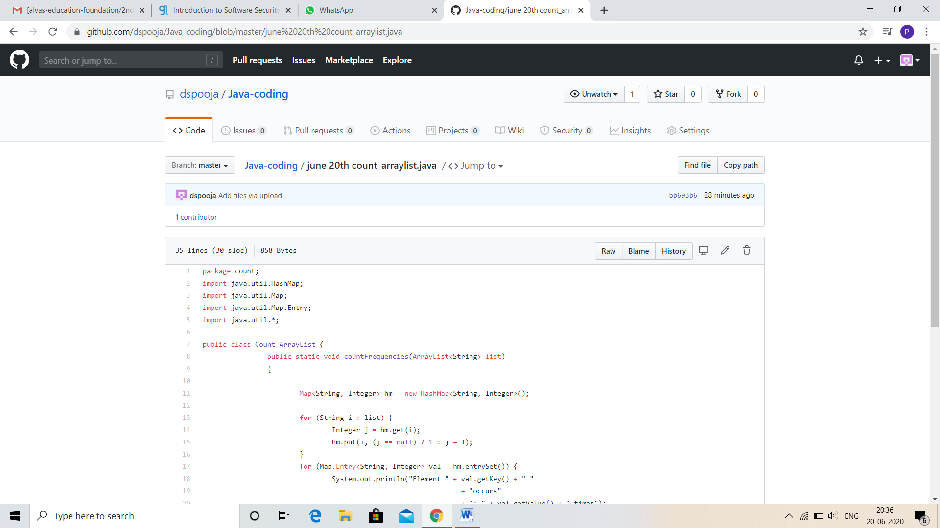

Problem statement 2:

Write a C Program to rotate an array by K positions.

Circular array rotation means rotating the elements in the array where one rotation operation moves the last element of the array to the first position and shifts all remaining elements to the right.

For example, consider the following array = [4, 5, 6],  
• Initial array [4, 5, 6]

• After one rotation [6, 4, 5]  
• After two rotations [5, 6, 4]

OUTPUT

Element at index 0: 5  
Element at index 1: 6  
Element at index 2: 4

Solution: Uploaded in github.

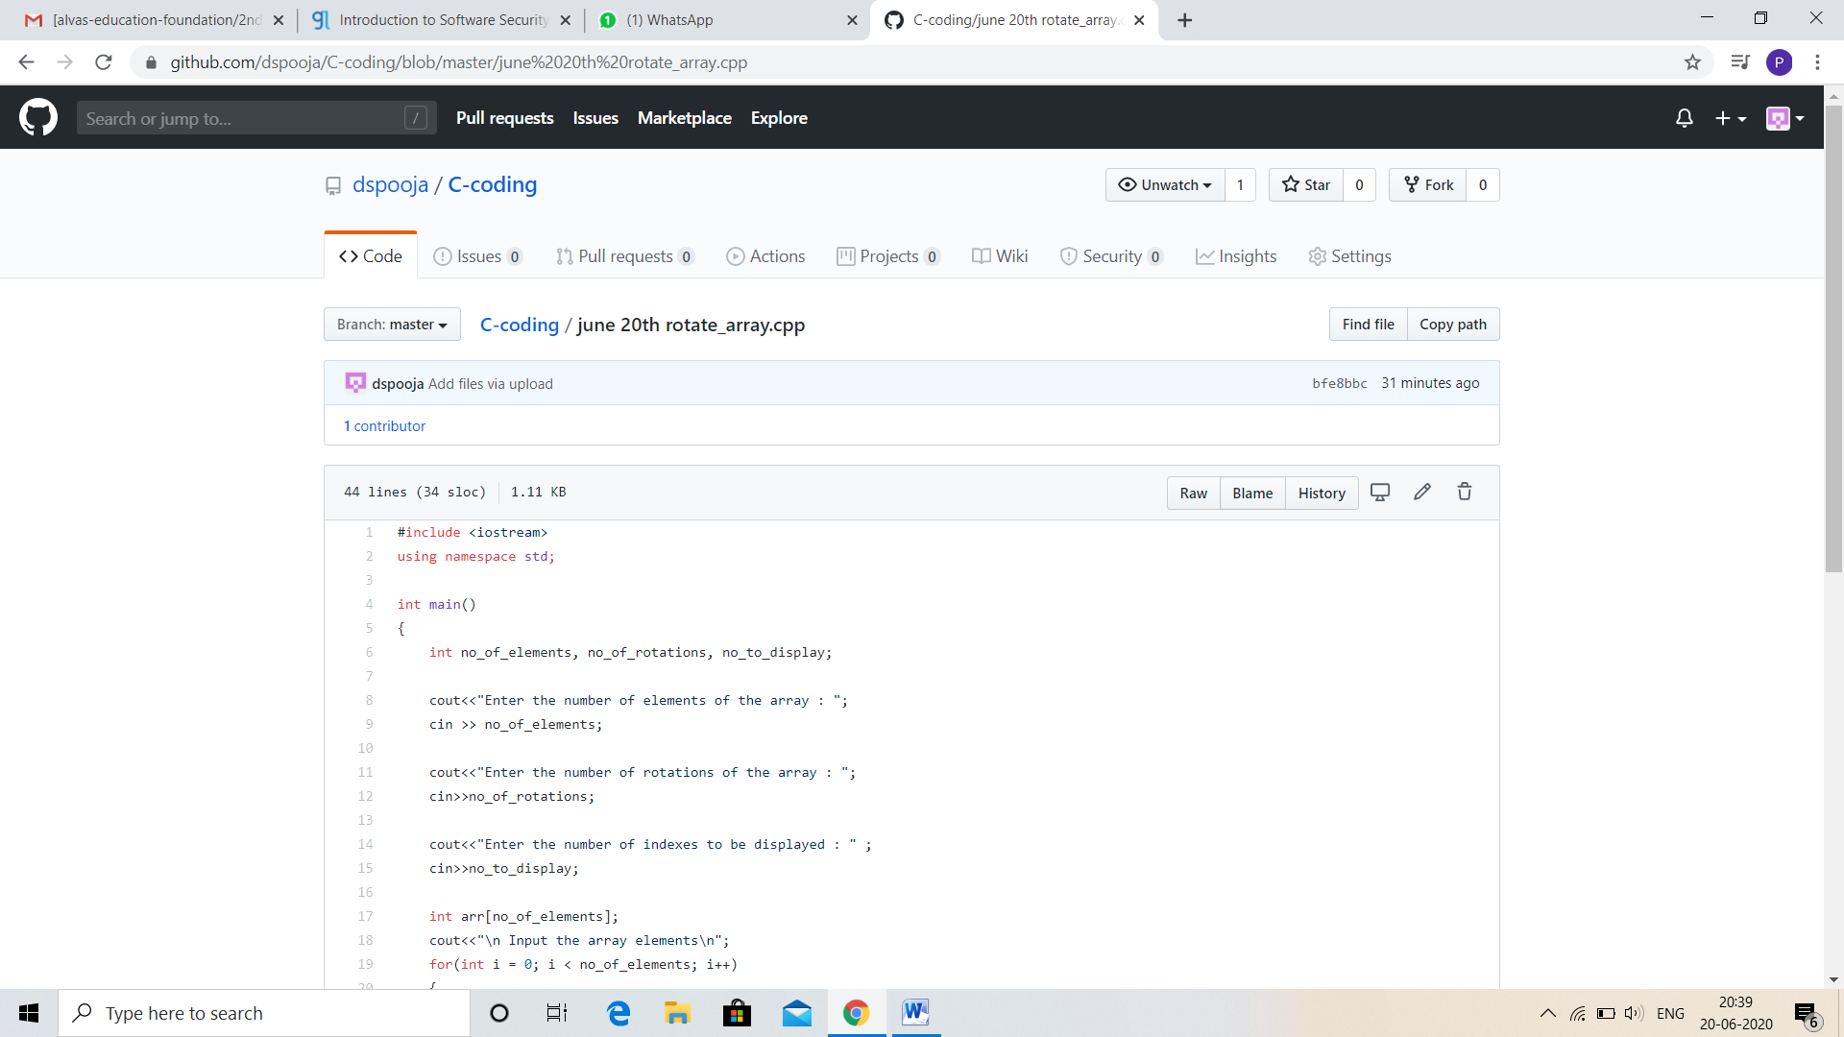

Problem statement 3:

Write a Java program to count number of bits to be flipped to convert A to B.

Given two numbers ‘a’ and b’. Write a program to count number of bits needed to be flipped to convert ‘a’ to ‘b’.  
**Example:**

Input: a = 10, b = 20  
Output: 4  
Binary representation of a is 000**0101**0  
Binary representation of b is 00010100  
We need to flip highlighted four bits in a  
to make it b.

Input: a = 7, b = 10  
Output: 3  
Binary representation of a is 0000**01**1**1**  
Binary representation of b is 00001010  
we need to flip highlighted three bits in a  
to make it b.

Solution: Uploaded in github.

